CS 305 Project One Template

Document Revision History

Version | Date | Author | Comments
1.0 | 1/25/2026 | Shawn Stover | Filled out all Sections

Client



Instructions
Submit this completed vulnerability assessment report. Replace the bracketed text with the relevant information. In this report, identify your security vulnerability findings and recommend the next steps to remedy the issues you have found.

- Respond to the five steps outlined below and include your findings.
- Respond using your own words. You may also include images or supporting materials. If you include them, make certain to insert them in the relevant locations in the document.
- Refer to the Project One Guidelines and Rubric for more detailed instructions about each section of the template.

Developer
Shawn Stover

1. Interpreting Client Needs
Determine your client’s needs and potential threats and attacks associated with the company’s application and software security requirements. Consider the following questions regarding how companies protect against external threats based on the scenario information:

- What is the value of secure communications to the company?
- Are there any international transactions that the company produces?
- Are there governmental restrictions on secure communications to consider?
- What external threats might be present now and in the immediate future?
- What modernization requirements must be considered, such as the role of open-source libraries and evolving web application technologies?

Artemis handles loads of highly sensitive data including client financial records, SSNs and tax information. Engaging in international transactions at all, even without access to such personal data creates a need that Artemis must follow global data protection standards such as GDPR while ensuring exposure of trade secrets is kept to a minimum. Encryption export laws are also imperative that they follow to ensure that they are not getting in trouble while encrypting and sending data. According to Cidot.eu, security should be embedded from the onset of the SDLC, not as an afterthought once the application is built. Security requirements should be planned out along the same lines as the functional requirements. (Codit, n.d.) The threats that Artemis must defend against are injection attacks, interception attacks, phishing and any vulnerabilities in third party libraries that are in use. Effort to minimize risk must include rigorous update practices and procedures to ensure that external libraries are staying up to date with current release. Maven’s own dependency check should be rigorously deployed against the code base to ensure that everything stays up to date and security holes are being patched. For Java specific applications, especially with this level of sensitive data, input validation is a must, and authentication must be completely secure and locked down. By using all of these approaches during development and post deployment maintenance, they can ensure that they are minimizing the risk of catastrophic data loss or system compromises.

2. Areas of Security
Refer to the vulnerability assessment process flow diagram. Identify which areas of security apply to Artemis Financial’s software application. Justify your reasoning for why each area is relevant to the software application.

Input Validation – Validating inputs is considered the very first line of defense against SQL Injections, XSS attacks, and data tampering. Validating inputs such as user credentials account numbers and transaction data ensures that only authorized users can access or modify financial records.

APIs – Artemis Financial operates APIs that serve both internal staff and external clients, secure APIs are one of the best ways to guard against attacks. Endpoints should be protected by authorization and authentication, and calls should be restricted by user role and access levels. Thios would help ensure that data is protected as it moves around and can only be accessed by the relevant parties after proper authentication.

Cryptography – Artemis needs to implement cryptography for both data that is in motion and at rest. With the degree of security needed for financial, SSNs and personal identifying information, Artemis needs to use standards like TLS 1.2 for data in transit and AES-256 for data that is at rest. These encryption strategies also align with regional data protection laws which allow them to abide by these laws while still having the data protection and encryption that they need.

Error Handling – Error handling should be complete and thorough. These ensure that data like server paths, vulnerable exception messages or database schemas are sent to users or potential attackers. Detailed error logging should only be done internally, generic error messages that are also vague should be displayed to users to ensure that the data is protected. These traits give them the ability to handle faults quickly and efficiently, while also ensuring that data is safe from outside attacks.

Code Quality – Secure coding patterns and good encapsulation should be enforced to ensure that the application is segmented properly, and roles are properly enforced for users and authentication. This ensures that users are restricted to only interfacing with their data and don’t end up with server-side functionality or have access to data belonging to other users. Principles such as least privilege and modular architecture ensure that back-end logic and sensitive data is protected.

3. Manual Review
Continue working through the vulnerability assessment process flow diagram. Identify all vulnerabilities in the code base by manually inspecting the code.

Input Validation

Input validation is not used in critical areas of the application such as GreetingController.java and CRUDController.java. User supplied data is accepted with any sanitization or validation. This creates vulnerabilities for injection based, XSS, and malformed input attacks. This should be mitigated by enforcement with annotations such as @Pattern, @NotBlank or incorporating a robust validation library such as Apache Commons Validator.

Use of HTTP GET for Data Submission is Not Secure

Also in GreetingController.java and CRUDController.java, Artemis uses HTTP Get commands to handle user input. This embeds sensitive data directly into the URL, which can be stored in history, logs, or exposed to the wrong parties. This is considered insecure when dealing with more sensitive data. Get should be replaced with POST to handle endpoints with input, and CSRF protection needs to be enabled to help improve data security.

No Authentication or Authorized Controls

All API endpoints that are accessible are usable without authentication, enforcing user identity or correct access control implementations. This creates a large vulnerability where unauthorized users can interact with sensitive operations or data. To fix these issues, Spring Security needs to be implemented, and endpoints need protection with annotations like @PreAuthorize to check user roles or privileges before allowing access.

No Error Handling
There is no structured error handling in controller classes and in DocData.java. SQL exceptions are also printed using e.printStackTrace(). This can reveal application details or cause crashes. Try-catch blocks should be used to ensure that things are being tested, and errors are being caught and use @ControllerAdvice to ensure that the error is being handed back to the system and a generic user error is fed to the user.

No Output Encoding for User Data

In GreetingController.java, input is injected using String.format() without using any output encoding. This output allows untrusted data to be returned to the client and have it also be rendered in the browser. This can create a vector for rendered XSS attacks. HTML or JSON should be used to encode the output to ensure that any special characters or malicious scripts are caught before being handed over and executed.

Hard-Coded Database Credentials

In DocData.java, all relevant database connection details, including the required username and password are hard coded directly into the code. This creates a massive risk if the code is committed into an environment that is visible on the internet or shared externally. Credentials should be called in the code using environment variables, or a secret management system that leaves them in a place where they are not exposed to the public.

Lack of Encryption for Sensitive Data

There are no indicators that data encryption is being used to help protect sensitive data either at rest, or during transport. When data is not encrypted sensitive data may be prone to being stored in plain text, easily readable by anyone that gains access to the file and its contents. The system needs to use HHTPs for client-server communication and AES-256 should be used as the standard for data encryption before and after transport, and when it is at rest.

Insecure SQL Setup

Although no queries are executed, JDBC is being executed without parameter binding that demonstrates a poor SQL setup for security. If read_document() gets expanded at some time in the future, the system could become vulnerable to SQL injection attacks. To make sure this doesn’t happen, all SQL queries should be used with PreparedStatement and proper sanitization to ensure that the query remains as safe as possible.

Poor Encapsulation and Naming Conventions

Classes such as customer.java and myDateTime.java do not follow standard naming conventions and expose fields without the appropriate access modifiers in place. Lowercase class names as well as the practice of leaving fields as package private create possible exposure conditions for data. All fields should be set to private and proper getter and setter methods should be fit into the codebase to fix these issues. Class names should use PascalCase as outlined in Java Best Practices.

No Logging or Monitoring

There is no evidence of a logging framework or tracking of any events that would log server access attempts or server errors. Malicious activity or errors that may crash the system can easily go unnoticed. Enabling logging and integrating a proper form of monitoring with help ensure that the server and its files stay secure for both clients and the company alike.

4. Static Testing
Run a dependency check on Artemis Financial’s software application to identify all security vulnerabilities in the code. Record the output from the dependency-check report. Include the following items:

- The names or vulnerability codes of the known vulnerabilities
- A brief description and recommended solutions provided by the dependency-check report
- Any attribution that documents how this vulnerability has been identified or documented previously

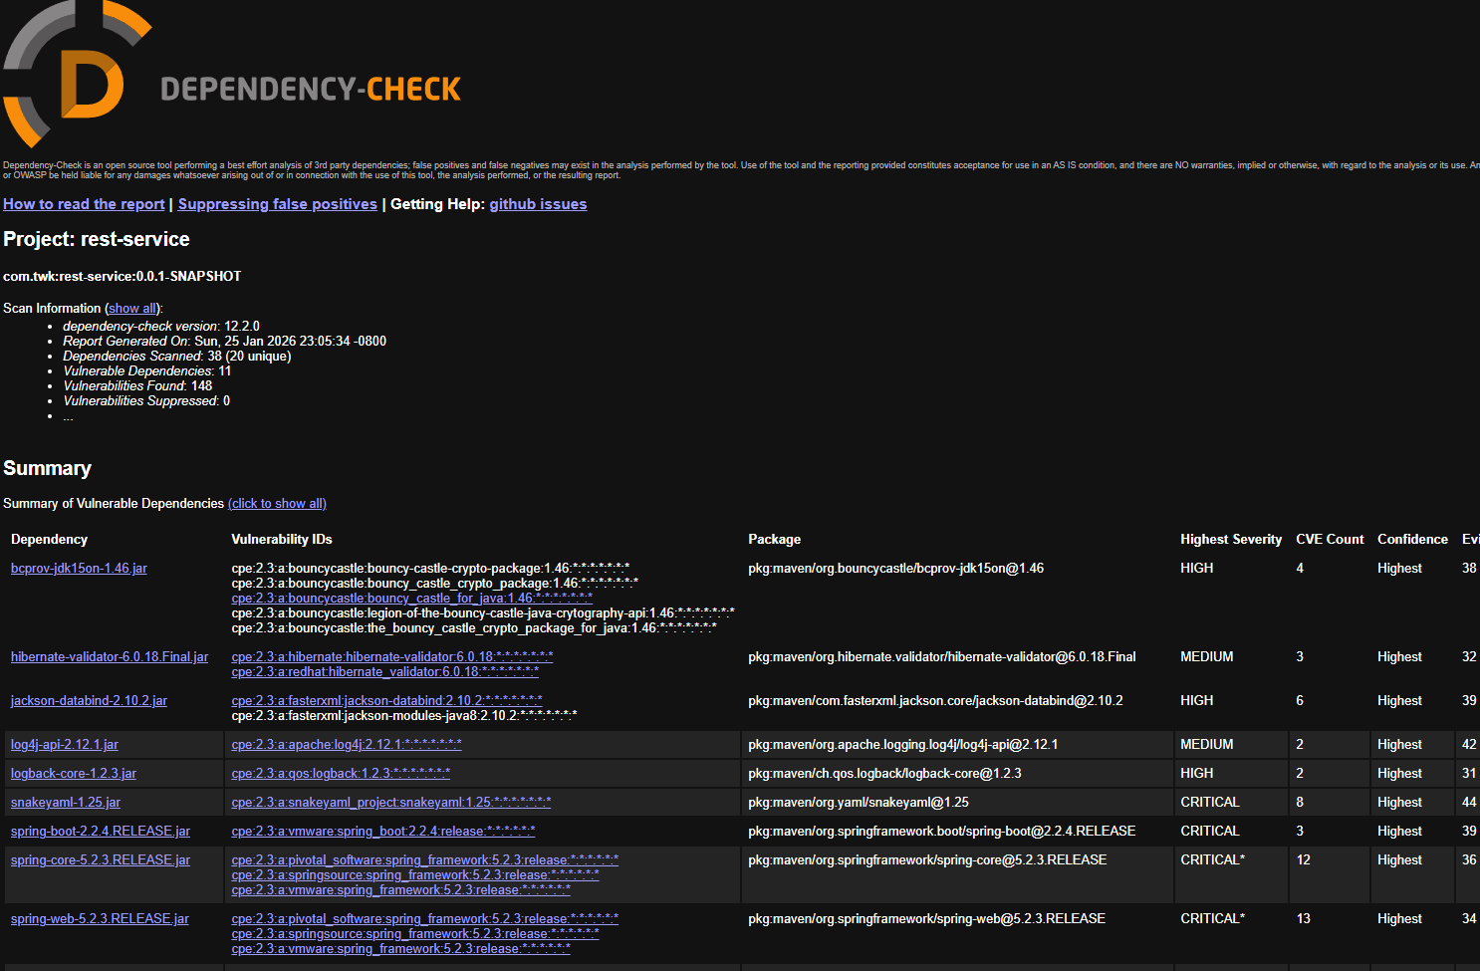

Dependency | Vulnerability ID | Severity | CVE Count
bcprov-jdk15on-1.46.jar | CVE-2016-1000338, CVE-2020-15522, CVE-2023-33202, CVE-2015-7940 | HIGH | 4
hibernate-validator-6.0.18.Final.jar | CVE-2025-35036  CVE-2023-1932  CVE-2020-10693 | MEDIUM | 3
jackson-databind-2.10.2.jar | CVE-2020-25649  CVE-2020-36518  CVE-2021-46877  CVE-2022-42003  CVE-2022-42004  CVE-2022-35116 | HIGH | 6
log4j-api-2.12.1.jar | CVE-2020-9488  CVE-2025-68161 | MEDIUM | 2
logback-core-1.2.3.jar | CVE-2021-42550 | HIGH | 4
snakeyaml-1.25.jar | CVE-2022-1471  CVE-2017-18640  CVE-2022-25857  CVE-2022-38749  CVE-2022-38751  CVE-2022-41854  CVE-2022-38750 | CRITICAL | 8
spring-boot-2.2.4.RELEASE.jar | CVE-2023-20873  CVE-2022-27772  CVE-2023-20883 | CRITICAL | 3
spring-core-5.2.3.RELEASE.jar | CVE-2022-22905  CVE-2024-22259  CVE-2021-22118  CVE-2020-5421  CVE-2022-22950  etc | CRITICAL | 12
spring-web-5.2.3.RELEASE.jar | CVE-2016-1000027  CVE-2022-22965  CVE-2024-22259  CVE-2021-22118  CVE-2020-5421  etc | CRITICAL | 13
tomcat-embed-core-9.0.30.jar | CVE-2020-1938  CVE-2024-50379  CVE-2024-52316  CVE-2024-56337  CVE-2025-24813  etc | CRITICAL | 47
tomcat-embed-websocket-9.0.30.jar | CVE-2020-1938  CVE-2024-50379  CVE-2024-52316  CVE-2024-56337  CVE-2025-24813  etc | CRITICAL | 48

bcprov-jdk15on-1.46.jar - Bouncy Castle 1.46 contains multiple cryptographic vulnerabilities that can allow forged signatures, key leakage, or denial-of-service attacks, and the fix is simply upgrading to version 1.73 or later.
hibernate-validator-6.0.18.Final.jar - Hibernate Validator 6.0.18.Final allows user-controlled data to be evaluated as Expression Language or bypass HTML-safety checks, creating risks of code injection and XSS, and the fix is upgrading to version 6.2.0 or later
jackson-databind-2.10.2.jar - Jackson-databind 2.10.2 contains multiple deserialization vulnerabilities that allow attackers to exploit unsafe gadget classes for remote code execution, and the fix is upgrading to a fully patched version such as 2.15+.
log4j-api-2.12.1.jar - Log4j-api 2.12.1 is affected by multiple vulnerabilities in the Log4j 2.x line that can enable denial-of-service or unsafe lookups in certain configurations, and the fix is upgrading to a fully patched release such as 2.17.2 or later.
logback-core-1.2.3.jar - Logback-core 1.2.3 contains vulnerabilities that allow attackers to trigger denial-of-service conditions through crafted log data, and the fix is upgrading to Logback 1.2.9 or later.
snakeyaml-1.25.jar - SnakeYAML 1.25 is vulnerable to unsafe YAML deserialization that can allow attackers to load arbitrary classes or trigger denial-of-service conditions, and the fix is upgrading to version 2.0 or later.
spring-boot-2.2.4.RELEASE.jar - Spring Boot 2.2.4.RELEASE contains multiple known vulnerabilities in its underlying Spring Framework components that can enable denial-of-service or unsafe data binding behavior, and the fix is upgrading to a fully patched version such as Spring Boot 2.7.x or 3.x.
spring-core-5.2.3.RELEASE.jar - Spring Core 5.2.3.RELEASE contains several known vulnerabilities in its data binding and request-processing components that can enable denial-of-service or unsafe expression handling, and the fix is upgrading to a fully patched version such as Spring Framework 5.3.x or 6.x.
spring-web-5.2.3.RELEASE.jar - Spring Web 5.2.3.RELEASE contains known vulnerabilities in request handling and data binding that can enable denial-of-service or unsafe expression evaluation, and the fix is upgrading to Spring Framework 5.3.x or 6.x.
tomcat-embed-core-9.0.30.jar - Tomcat-embed-core 9.0.30 contains multiple known vulnerabilities in request parsing and HTTP handling that can enable denial-of-service or information-exposure issues, and the fix is upgrading to Tomcat 9.0.80 or later
tomcat-embed-websocket-9.0.30.jar - Tomcat-embed-websocket 9.0.30 contains known WebSocket handling vulnerabilities that can lead to denial-of-service or improper request processing, and the fix is upgrading to Tomcat 9.0.80 or later.
5. Mitigation Plan
Interpret the results from the manual review and static testing report. Then identify the steps to mitigate the identified security vulnerabilities for Artemis Financial’s software application.

A practical mitigation plan for these vulnerabilities is to upgrade all outdated libraries to their latest secure versions, starting with a modern Spring Boot release so that Spring Core, Spring Web, Jackson, Tomcat, and logging components are automatically aligned and patched. Cryptographic risks from the old Bouncy Castle version should be addressed by upgrading to a current release and rotating any keys that may have been generated with the vulnerable library. After upgrading, configurations should be hardened by disabling unsafe deserialization, restricting Expression Language evaluation, validating all user input, and ensuring logging frameworks do not process untrusted data in risky ways. Finally, the application should undergo regression and security testing to confirm the fixes, and automated dependency scanning should be added to CI/CD to prevent similar issues from accumulating in the future. Error handling should be coded into the software and generic error messages handed out to users. Inputs should be sanitized and encrypted so that sensitive data is not at risk either at rest or in transport. Lastly, environment variables should be implemented so that hard coding of credentials can be undone.

References

Integrating Security in the Software Development Lifecycle (SDLC). (2024, November 20). Codit. https://www.codit.eu/blog/integrating-security-in-the-software-development-lifecycle-sdlc/

